CAS PY 106

Pre-session Note 5

Electric field near conductors

1. Conduction
2. At equilibrium, the conduction electrons in conductor move randomly but there is no net flow of charge in any direction
3. If there is a change in external electric field the conductor is exposed to the conduction electrons respond by redistributing themselves, very quickly coming to a new equilibrium distribution
4. At equilibrium, E = 0, these conditions apply
5. There is no electric field inside the solid part of the conductor
6. 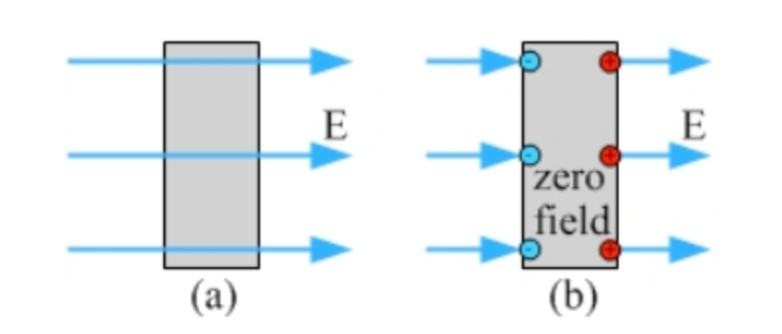
7. If electric field penetrates into conductor, conduction electrons immediately respond to the field
8. Because F=qE and electrons are negative, electrons feel a force opposite to the field
9. Shown in the figure, there is a net movement of electrons to the region where the field enters the conductor
10. The field lines end at the electrons at the surface, so E = 0 within the conductor
11. This redistribution of electrons leaves positive charge at the other side of the conductor, so field lines start up again there and go away from conductor
12. The electric field at the surface of the conductor is perpendicular to the surface
13. 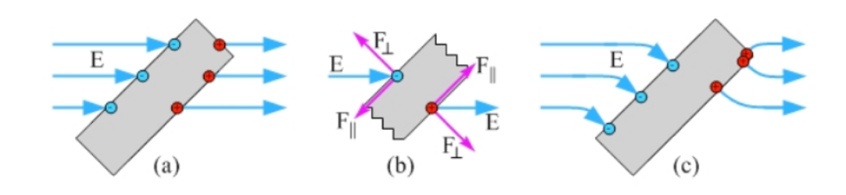
14. If electric field lines end at the surface of conductor but not perpendicular to the surface, in figure a, the charges at the surface feel force from the field
15. Figure b shows that the component of the force parallel to the surface causes charges to flow along the surface, carrying the field lines with them
16. The charges are in equilibrium when the electric field lines are perpendicular to the surface, shown in figure c
17. Even though electrons at the surface still feel a force component perpendicular to the surface that is trying to remove electrons from the conductor, this will not happen in most cases due to the insulating materials surrounding the conductor
18. If the conductor is charged, excess charge lies only at the surface of the conductor
19. Statement is a consequence of the fact that at equilibrium E = 0 within the conductor
20. If there was excess charge in bulk of conductor field lines would either start there, if positive, or end there, if negative
21. This non-zero field inside conductor would cause charges to move to surface to bring field to zero within the conductor
22. Charge density is highest, and electric field is strongest, on pointy parts of a conductor
23. 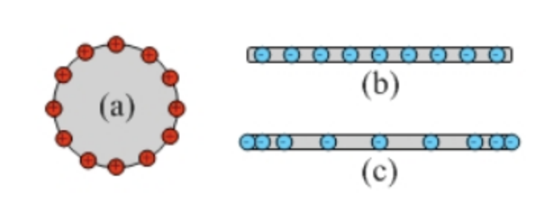
24. In figure a, metal sphere has net positive charge.
25. At equilibrium, the excess charge is distributed uniformly over the surface of the sphere. Moving any of the charges around results in forces that act on these charges, driving them back to equilibrium distribution
26. In contrast, figure b shows excess charge distributed evenly along a conducting rod. The charge at the center experiences no net force from other charges but other charges experience net forces that push them towards the ends of the rod, resulting figure c.
27. When point charge of +Q is placed at center of metal sphere that has no net charge, 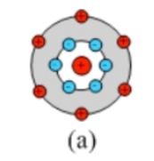 is the right figure
28. Enough conduction electrons in sphere are attracted to the inner surface that field lines from center +Q charge do not penetrate into the sphere, leaving net positive charge +Q on the outer surface.